LOG ANALYSIS & ATTACK DETECTION

ANALYST: NWADIALOR JESSICA CHINEDU
DATE: 18th April 2026
TARGET: UBUNTU (192.168.100.18)
ATTACK:Kali Linux (HYDRA.192.168.100.15)
TOOLS:Splunk,Hydra.
—------------------------------------------------------------------------------------------------------------------------

EXECUTIVE SUMMARY
The purpose of the exercise is to detect unauthorized access attempts.A brute-force attack was successfully identified using the Security Information and Event Management tool(Splunk).

INFRASTRUCTURE SETUP & SIEM DEPLOYMENT.

1.I installed Splunk Enterprise on the host/server.I downloaded it from my windows browser and imported it into my Ubuntu VM.And did some settings on the terminal.went back to windows browser and opened Splunk logged in,Configured the server to collect system logs,auth.log.This was done by setting up a Data Inputs in Splunk to monitor /var/log/,this ensured that all SSH attempts would be indexed in real-time.
2.I set both my Kali and Ubuntu on Bridged Adapter,because i used my windows
Browser for Splunk.

INCIDENT ANALYSIS (SSH BRUTE-FORCE VIA HYDRA)

1.Using Hydra, I launched a brute force attack against the target SSH(Ubuntu) service using this command hydra -l vboxuser -P /usr/share/wordlists/rockyou.txt ssh://192.168.100.18 on my Kali Terminal.

2. The SSH was open on the UBUNTU Terminal.

3.I checked Splunk in my windows Browser and searched for :
source=“/var/log/auth.log” “failed password” 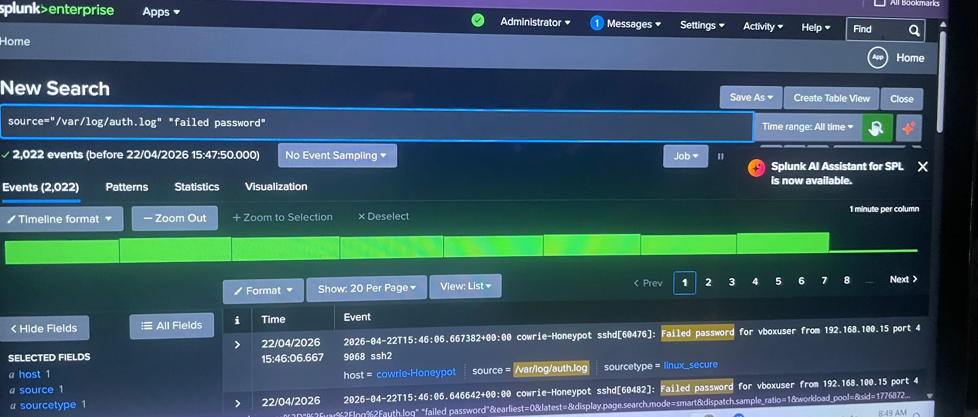

source=“/var/log/auth.log” “failed password” | timechart count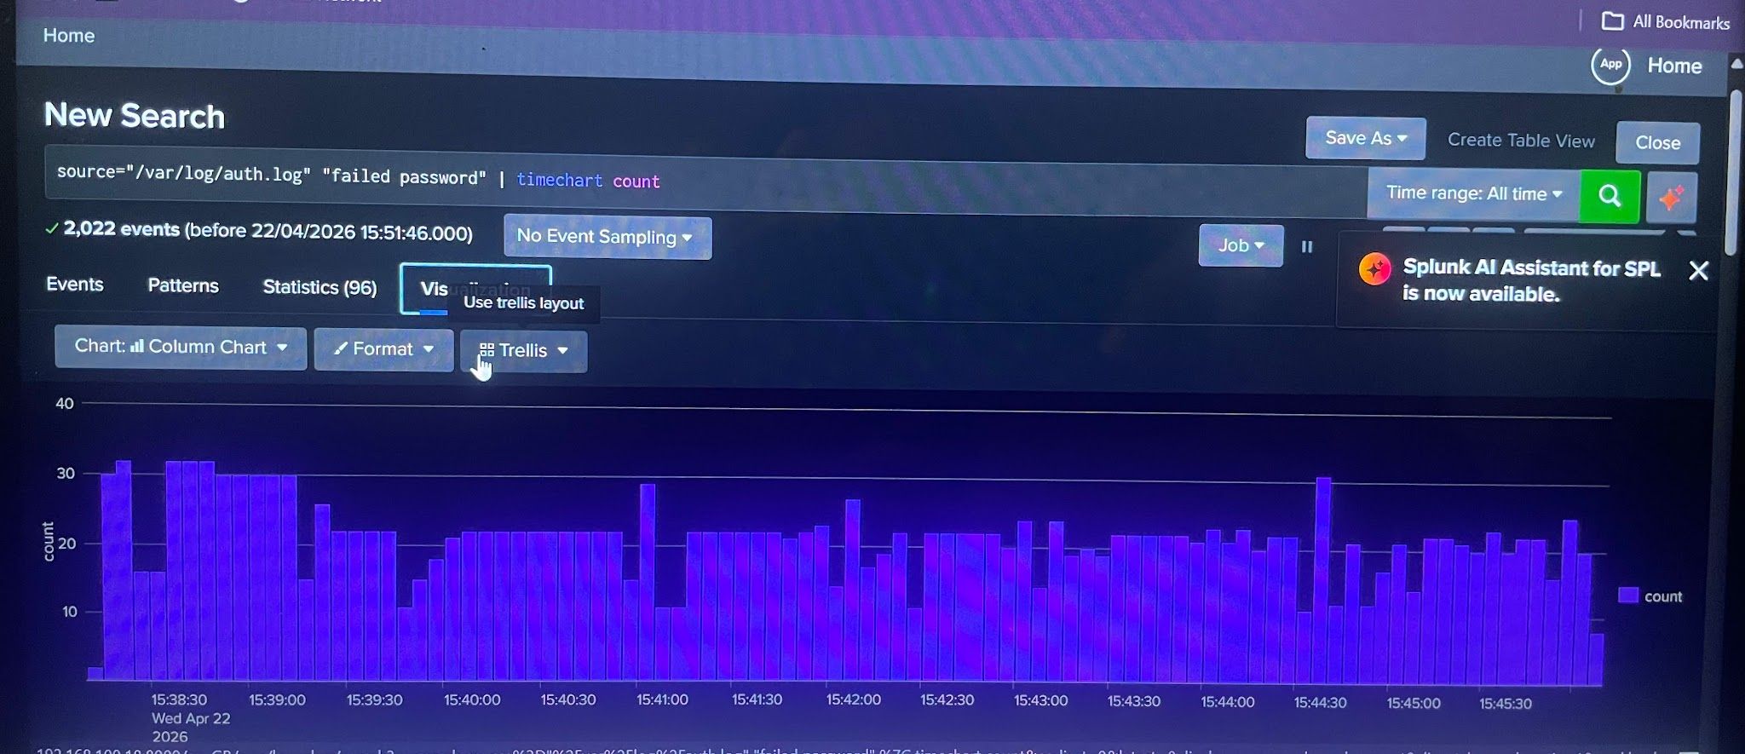
Using Splunk, a brute-force attack was detected on the Ubuntu server.The SIEM identified over 2000 failed password events originating from Kali Linux Hydra in a matter of minutes,successfully triggering an incident alert.

AI TOOL JUSTIFICATION AND RISK ASSESSMENT REPORT.
TOOLS:Adversarial Robustness Toolbox(ART),python,tensor flow,Numpy.

What is ART
ART is a tool developed by IBM that is used to test, attack, and strengthen the security of AI models.

I trained a neural network model (MLP) using the MNIST dataset and then applied the HopSkipJump attack to test its vulnerability.
After the attack, the model’s accuracy dropped significantly from 0.975 to 0.011111.

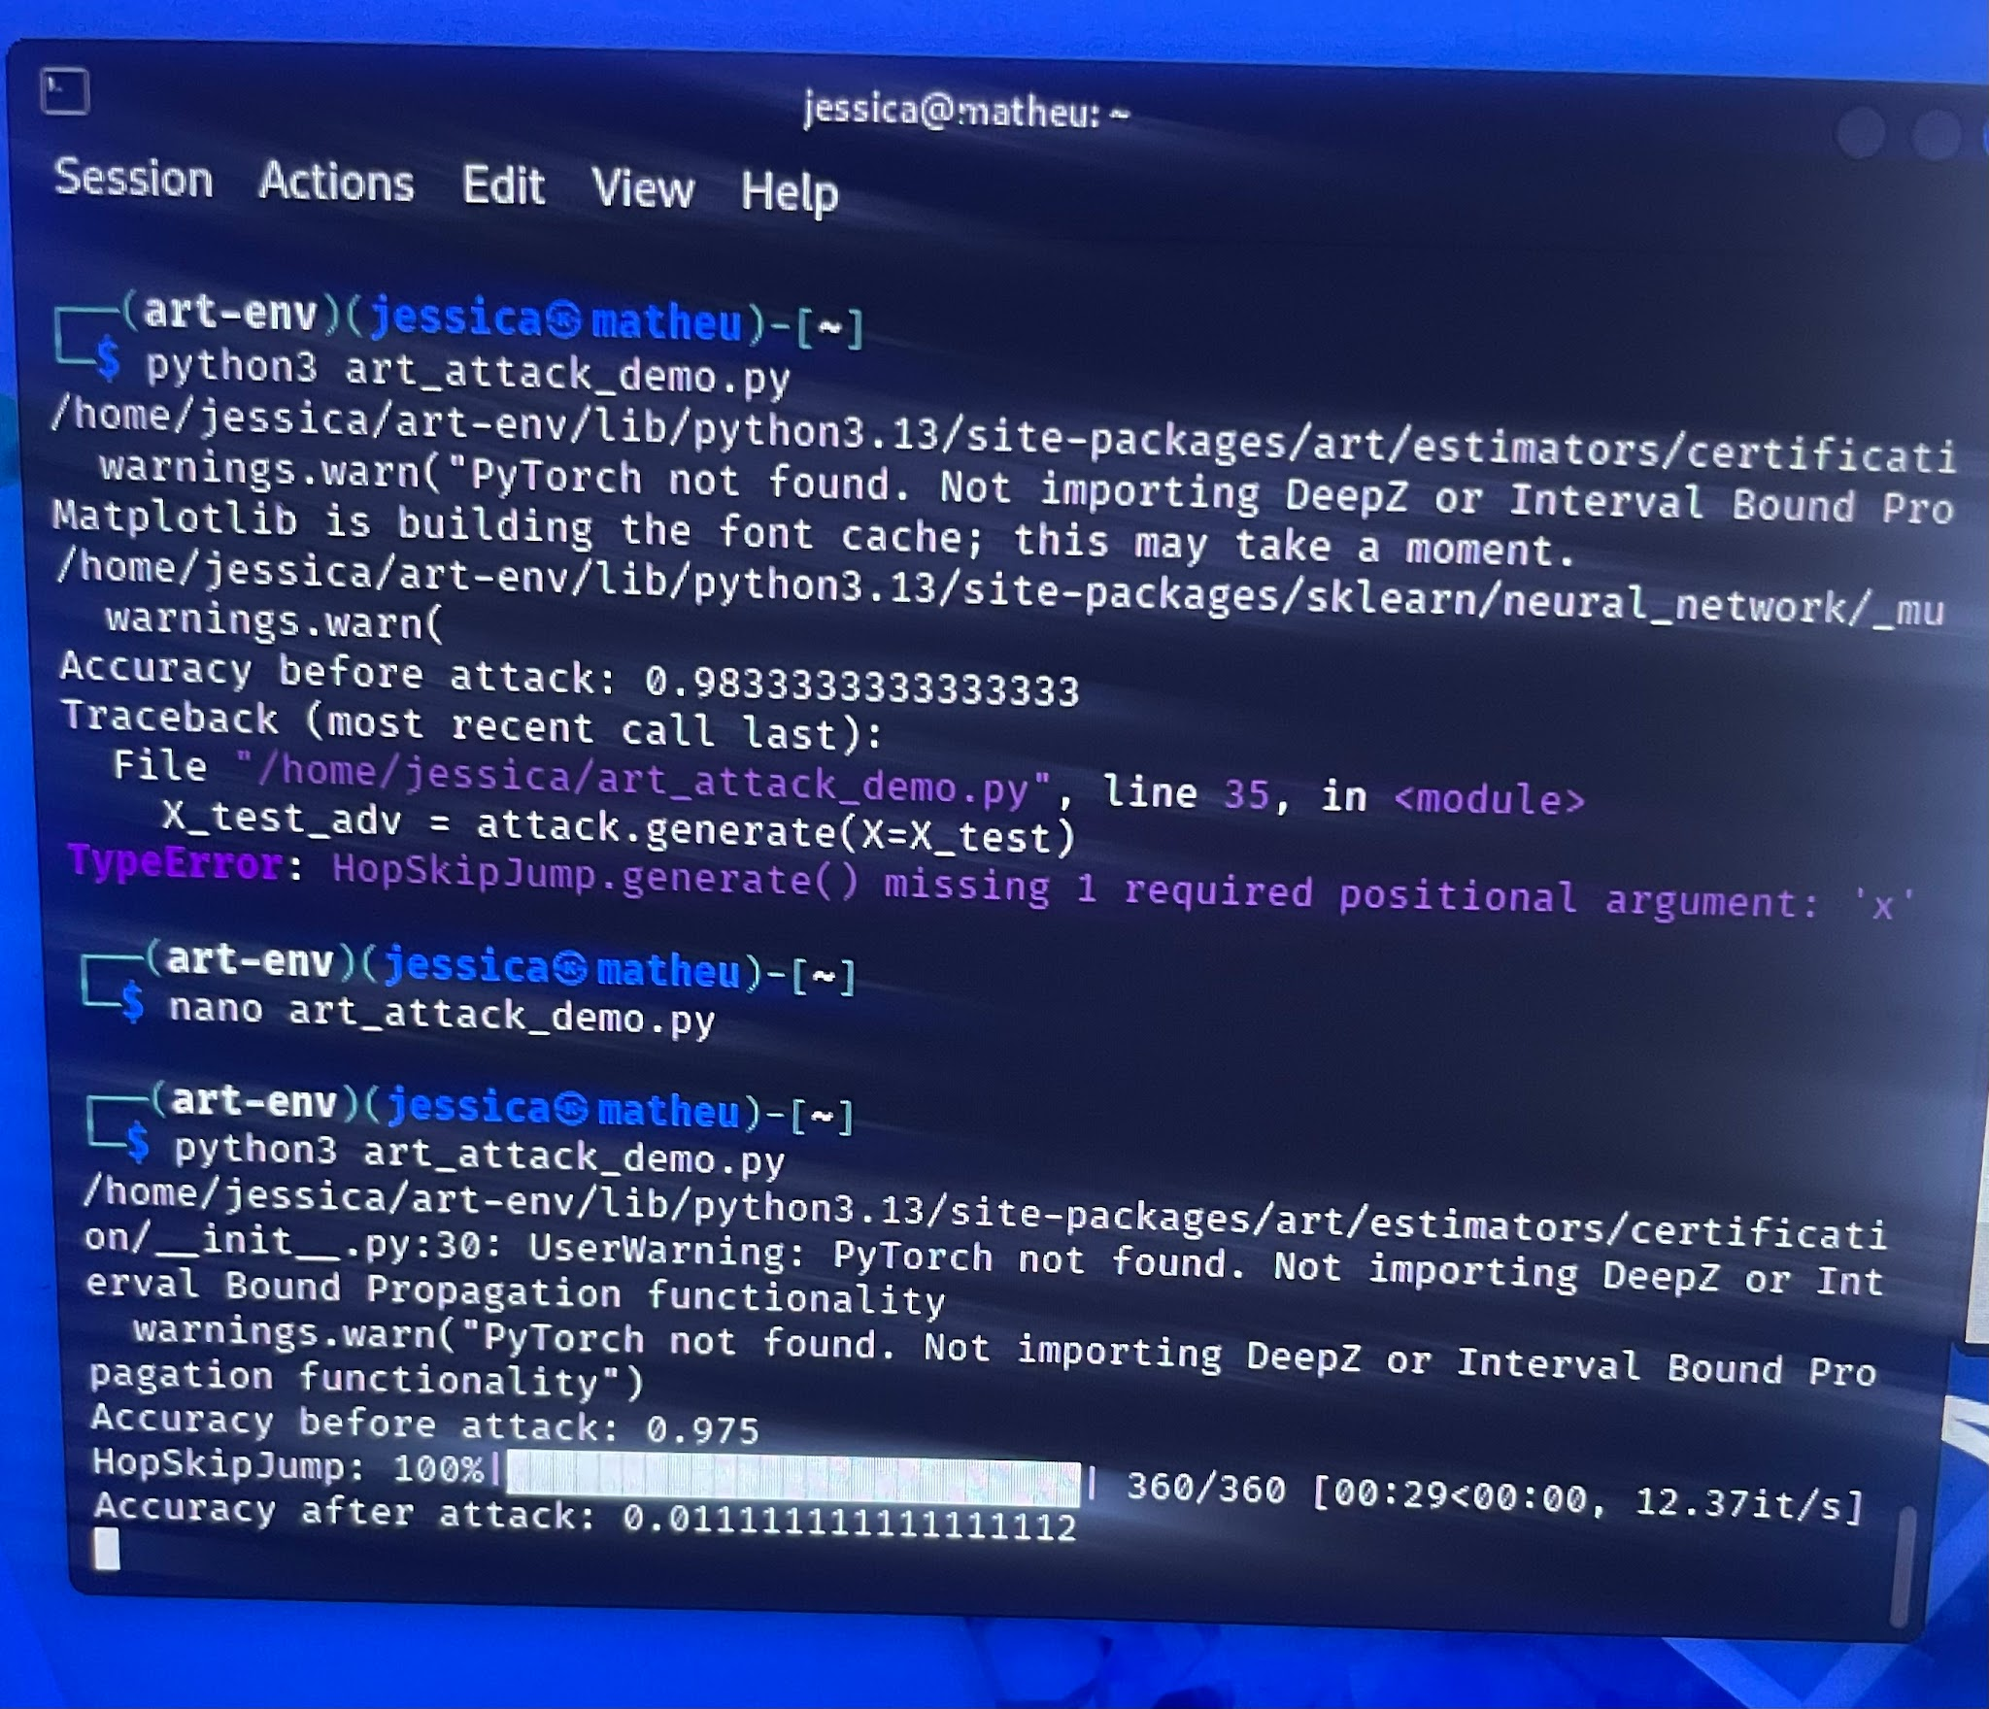

The attack also generated images showing original data compared to adversarial (modified)
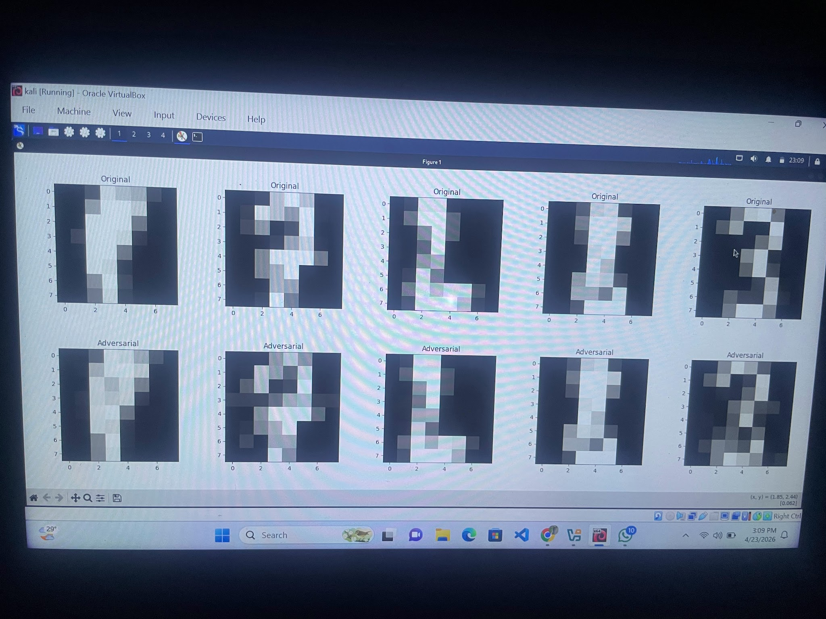

Why it is dangerous
This attack is dangerous because it works without access to the model’s internal structure. It only relies on interacting with the model and observing its outputs.

DANGERS:
Such attacks can be used to trick real systems like antivirus software, fraud detection systems, and facial recognition technologies.

DEFENCE:
Defensive strategies include adversarial training, limiting how often the model can be queried, and monitoring for unusual or suspicious activity.

LEGAL AND ETHICAL CONSIDERATIONS:
These types of attacks should only be performed in controlled and authorized environments.

CONCLUSION:
The attack was black box, meaning the attacker never had access to the model’s code or internal parameters. They only interacted with it and used its responses to manipulate it. This reflects how real attackers target AI systems through public interfaces such as APIs.

